**Batch: E-2**

**Roll No.: 16010123325**

**Experiment / assignment / tutorial No. 7**

**Grade: AA / AB / BB / BC / CC / CD /DD**

**Signature of the Staff In-charge with date**

**Title:** Implementation of BST & Binary tree traversal techniques.

**Objective:** To Understand and Implement Binary Search Tree along with Insertion, Deletion and Preorder, Postorder and Inorder Traversal Techniques.

**Expected Outcome of Experiment:**

|  |  |
| --- | --- |
| **CO** | **Outcome** |
| 1 | Explain the different data structures used in problem solving |

**Books/ Journals/ Websites referred:**

1. *Fundamentals Of Data Structures In C –* Ellis Horowitz, Satraj Sahni, Susan Anderson-Fred
2. *An Introduction to data structures with applications –* Jean Paul Tremblay, Paul G. Sorenson
3. *Data Structures A Pseudo Approach with C –* Richard F. Gilberg & Behrouz A. Forouzan
4. https://[www.geeksforgeeks.org/binary-tree-data-structure/](http://www.geeksforgeeks.org/binary-tree-data-structure/)
5. https://[www.thecrazyprogrammer.com/2015/03/c-program-for-binary-search-](http://www.thecrazyprogrammer.com/2015/03/c-program-for-binary-search-) tree-insertion.html

**Abstract**:

**A tree** is a non- linear data structure used to represent hierarchical relationship existing among several data items. It is a finite set of one or more data items such that, there is a special data item called the root of the tree. Its remaining data items are partitioned into number of mutually exclusive subsets, each of which is itself a tree, and they are called subtrees.

**A binary tree** is a finite set of nodes. It is either empty or It consists a node called root with two disjoint binary trees-Left subtree, Right subtree. The Maximum degree of any node is 2

**A Binary Search Tree** is a node-based binary tree data structure in which the left subtree of a node contains only nodes with keys lesser than the node’s key. The right subtree of a node contains only nodes with keys greater than the node’s key. The left and right subtree each must also be a binary search tree.

**Related Theory: -**

**Algorithm: Preorder Traversal of BST**

1. Start at the root node
2. Visit the root node and print its value
3. Recursively traverse the left subtree
4. Recursively traverse the right subtree

**Algorithm: Postorder Traversal of BST**

1. Start at the root node
2. Recursively traverse the left subtree
3. Recursively traverse the right subtree
4. Visit the root node and process it

**Algorithm: Inorder Traversal of BST**

* 1. Start at the root node
  2. Recursively traverse the left subtree
  3. Visit the root node and process it
  4. Recursively traverse the right subtree

**An example BST :**

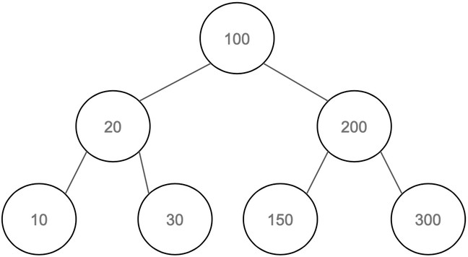

**Preorder Traversal:**

# 100, 20, 10, 30, 200, 150, 300

**Postorder Traversal:**

# 10, 30, 20, 150, 300, 200, 100

**Inorder Traversal:**

# 10, 20, 30, 100, 150, 200, 300

**Algorithm for Implementation of BST:**

1. **Node Structure Definition**
   * Define a structure TreeNode with data (int), leftChild (pointer to left subtree), rightChild (pointer to right subtree)
2. **Create Node**
   * Allocate memory for a new node.
   * Set data to value and both children to NULL.
   * Return the new node pointer.
3. **Insert Node**
   * If root is NULL, create and return a new node
   * If value < root->data, recursively insert in the left subtree
   * If value > root->data, recursively insert in the right subtree
   * Return the root
4. **Search Node**
   * If root is NULL, return false else root->data == value, return true
   * If value < root->data, search in the left subtree
   * If value > root->data, search in the right subtree
5. **Inorder Traversal**
   * If root is not NULL:
     1. Traverse the left child.
     2. Print root->data.
     3. Traverse the right child.
6. **Main Function**
   * Initialize root = NULL and use a menu to perform insert, search, and traversal operations

**Implementation Details:**

1. **Enlist all the Steps followed and various options explored.**
   1. **Define the TreeNode Structure**:
      * Created a structure TreeNode with three members: data, leftChild, and rightChild
   2. **Node Creation**:
      * Implemented the createNode function to allocate memory for a new node and initialize its data and child pointers
   3. **Insertion Functionality**:
      * Developed the insertNode function to insert a value into the BST. It recursively finds the correct position based on value comparisons
   4. **Search Functionality**:
      * Implemented the searchNode function to find a value in the tree. It traverses left or right based on comparisons and outputs whether the value was found
   5. **Traversal Functions**:
      * Created three traversal functions:

Inorder Traversal: Visits left child, root, then right child.

Preorder Traversal: Visits root, left child, then right child.

Postorder Traversal: Visits left child, right child, then root.

* 1. **Menu System**:
     + Designed a loop in main to display a menu for user interaction, allowing them to choose various operations like inserting, searching, or traversing the tree
  2. **User Input Handling**:
     + Used scanf to accept user input for different operations, ensuring each choice is processed accordingly

**Assumptions made for Input:**

1. **Valid Integer Input**: It is assumed that users will input valid integers when prompted.
2. **No Duplicate Values**: The program does not handle duplicate values. It assumes that each value inserted will be unique.
3. **Continuous Operation**: The program assumes the user will continuously choose options until they decide to exit.

**Built-In Functions Used:**

1. malloc( ): Allocates memory for a new node in the tree
2. printf( ): Displays output to the console
3. scanf( ) : Reads user input from the console
4. exit( ): Terminates the program.

**Program source code for Implementation of BST & Binary tree traversal techniques :**

#include <stdio.h>

#include <stdlib.h>

typedef struct Node {

    int data;

    struct Node* left;

    struct Node* right;

} Node;

typedef struct {

    Node* root;

} BST;

BST* create() {

    BST* bst = (BST*)malloc(sizeof(BST));

    bst->root = NULL;

    return bst;

}

BST* insert(BST* bst, int data) {

    Node* node = (Node*)malloc(sizeof(Node));

    node->data = data;

    node->left = NULL;

    node->right = NULL;

    if (bst->root == NULL) {

        bst->root = node;

    } else {

        Node* curr = bst->root;

        Node* parent = NULL;

        while(curr != NULL) {

            parent = curr;

            if (data < curr->data) {

                curr = curr->left;

            } else {

                curr = curr->right;

            }

        }

        if (data < parent->data) {

            parent->left = node;

        } else {

            parent->right = node;

        }

    }

    return bst;

}

void search(BST* bst, int data) {

    Node* curr = bst->root;

    while (curr != NULL) {

        if (data == curr->data) {

            printf("Found %d in the BST\n", data);

            return;

        } else if (data < curr->data) {

            curr = curr->left;

        } else {

            curr = curr->right;

        }

    }

    printf("%d not found in the BST\n", data);

}

void inorder(Node* node) {

    if (node != NULL) {

        inorder(node->left);

        printf("%d ", node->data);

        inorder(node->right);

    }

}

void preorder(Node* node) {

    if (node != NULL) {

        printf("%d ", node->data);

        preorder(node->left);

        preorder(node->right);

    }

}

void postorder(Node* node) {

    if (node != NULL) {

        postorder(node->left);

        postorder(node->right);

        printf("%d ", node->data);

    }

}

int main() {

    BST* bst = create();

    int choice, data;

    while (1) {

        printf("1. Insert node\n");

        printf("2. Search for node\n");

        printf("3. Perform inorder traversal\n");

        printf("4. Perform preorder traversal\n");

        printf("5. Perform postorder traversal\n");

        printf("6. Exit\n");

        printf("Enter your choice: ");

        scanf("%d", &choice);

        switch (choice) {

            case 1:

                printf("Enter the value to insert: ");

                scanf("%d", &data);

                bst = insert(bst, data);

                break;

            case 2:

                printf("Enter the value to search for: ");

                scanf("%d", &data);

                search(bst, data);

                break;

            case 3:

                printf("Inorder: ");

                inorder(bst->root);

                printf("\n");

                break;

            case 4:

                printf("Preorder: ");

                preorder(bst->root);

                printf("\n");

                break;

            case 5:

                printf("Postorder: ");

                postorder(bst->root);

                printf("\n");

                break;

            case 6:

                return 0;

            default:

                printf("Invalid choice. Please try again.\n");

        }

    }

    return 0;

}

**Output Screenshots for Each Operation:**

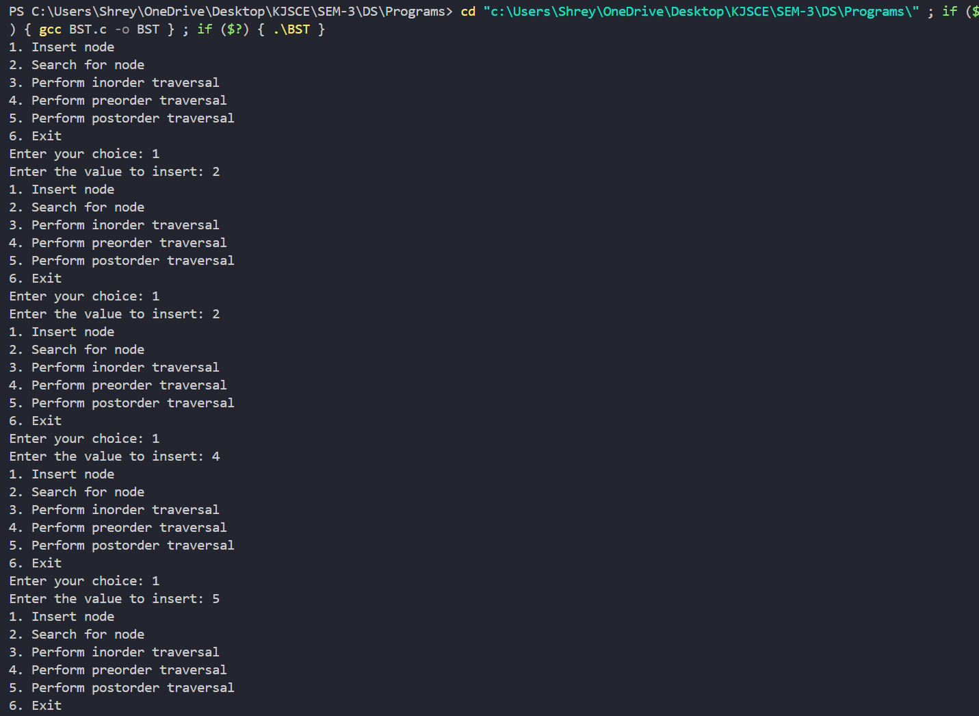

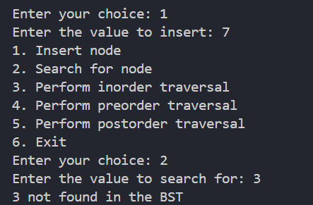

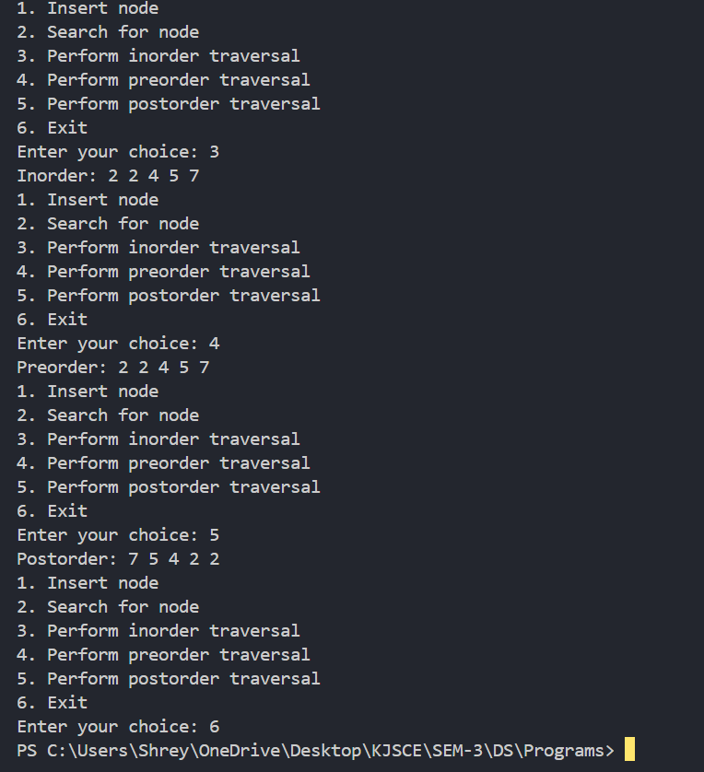

**Conclusion:-**

**The above program highlights the implementation of a Binary Search Tree in C with functions of search and tree traversals.**

**PostLab Questions:**

1. **Write an ADT for tree data structure**

Value Definition

Abstract typedef TreeType <ElementType> Condition: None

Operator Definition

* + Abstract TreeType create <>

**Precondition:** None

**Postcondition:** Set root node to NULL

* + Abstract TreeType insert <ElementType el>

**Precondition:** A tree has been created

**Postcondition:** el inserted in the correct position

* + Abstract Boolean search <ElementType el>

**Precondition:** A tree has been created

**Postcondition:** Returns true if the element el is found in the tree, otherwise returns false

* + Abstract void Inorder < >

**Precondition:** A tree has been created and contains at least one element **Postcondition:** Returns a list of the tree’s elements in inorder (left subtree, root, right subtree)

* + Abstract void Preorder < >

**Precondition:** A tree has been created and contains at least one element **Postcondition:** Returns a list of the tree’s elements in preorder (root, left subtree, right subtree)

* + Abstract void Postorder < >

**Precondition:** A tree has been created and contains at least one element **Postcondition:** Returns a list of the tree’s elements in postorder (left subtree, right subtree, root)

1. **Write a program to count the nodes in the Binary tree Code-**

#include <stdio.h> #include <stdlib.h>

struct TreeNode { int data;

struct TreeNode* leftChild; struct TreeNode* rightChild;

};

typedef struct TreeNode TreeNode;

TreeNode* createNode(int *value*)

{

TreeNode* newNode = (TreeNode*)malloc(sizeof(TreeNode)); newNode->data = *value*;

newNode->leftChild = NULL; newNode->rightChild = NULL; return newNode;

}

TreeNode* insertNode(TreeNode* *root*, int *value*)

{

if (*root* == NULL)

{

return createNode(*value*);

}

if (*value* < *root*->data)

{

*root*->leftChild = insertNode(*root*->leftChild, *value*);

}

else if (*value* > *root*->data)

{

*root*->rightChild = insertNode(*root*->rightChild, *value*);

}

return *root*;

}

int countNodes(TreeNode* *root*)

{

if (*root* == NULL)

{

return 0;

}

return 1 + countNodes(*root*->leftChild) + countNodes(*root*->rightChild);

}

int main()

{

TreeNode* root = NULL; int choice, value;

while (1)

{

printf("\nMenu:\n"); printf("1. Insert Node\n"); printf("2. Count Nodes\n"); printf("3. Exit\n"); printf("Enter your choice: "); scanf("*%d*", &choice);

switch (choice)

{

case 1:

printf("Enter value to insert: "); scanf("*%d*", &*value*);

root = insertNode(root, value); break;

case 2:

printf("The total number of nodes in the tree: *%d*\n", countNodes(root));

break; case 3:

printf("Exiting...\n"); exit(0);

default:

printf("Invalid choice. Please try again.\n");

}

}

return 0;

}

**Output-**

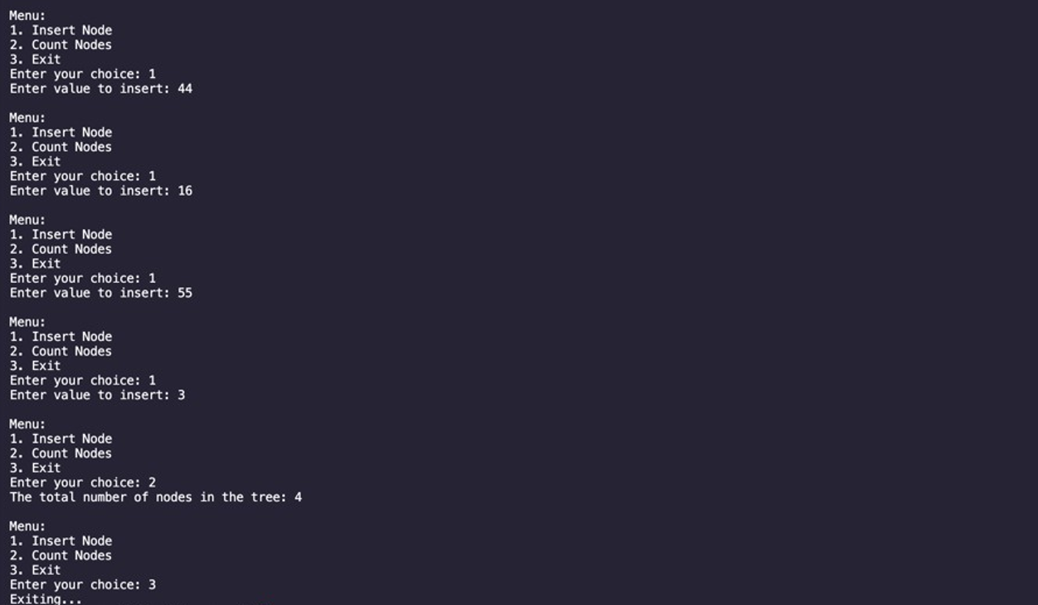

1. **Write a program to find the height of the Binary tree.**

**Code-**

#include <stdio.h> #include <stdlib.h>

struct TreeNode { int data;

struct TreeNode* leftChild; struct TreeNode* rightChild;

};

typedef struct TreeNode TreeNode; TreeNode* createNode(int *value*)

{

TreeNode* newNode = (TreeNode*)malloc(sizeof(TreeNode)); newNode->data = *value*;

newNode->leftChild = NULL; newNode->rightChild = NULL; return newNode;

}

TreeNode* insertNode(TreeNode* *root*, int *value*)

{

if (*root* == NULL)

{

return createNode(*value*);

}

if (*value* < *root*->data)

{

*root*->leftChild = insertNode(*root*->leftChild, *value*);

}

else if (*value* > *root*->data)

{

*root*->rightChild = insertNode(*root*->rightChild, *value*);

}

return *root*;

}

int findHeight(TreeNode* *root*)

{

if (*root* == NULL)

{

return -1;

}

int leftHeight = findHeight(*root*->leftChild); int rightHeight = findHeight(*root*->rightChild);

return 1 + (leftHeight > rightHeight ? leftHeight : rightHeight);

}

int main()

{

TreeNode* root = NULL; int choice, value;

while (1)

{

printf("\nMenu:\n"); printf("1. Insert Node\n");

printf("2. Find Height of the Tree\n"); printf("3. Exit\n");

printf("Enter your choice: "); scanf("*%d*", &choice);

switch (choice)

{

case 1:

printf("Enter value to insert: "); scanf("*%d*", &*value*);

root = insertNode(root, value); break;

case 2:

printf("The height of the tree is: *%d*\n", findHeight(root)); break;

case 3:

printf("Exiting...\n"); exit(0);

default:

printf("Invalid choice. Please try again.\n");

}

}

return 0;

}

**Output-**

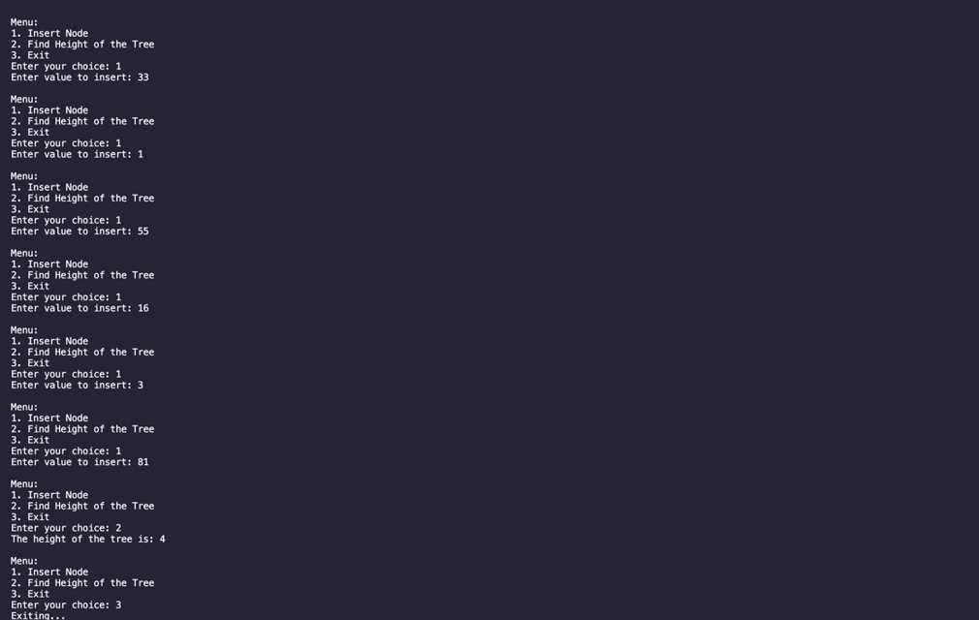

1. **The preorder traversal sequence of a binary search tree is 30, 20, 10, 15, 25, 23, 39, 35, 42. Construct the Binary Search Tree and perform the Postorder Traversal for the same.**

